Comments on Portfolio system design: Richard Duan (0481 719 796)

1. Database design

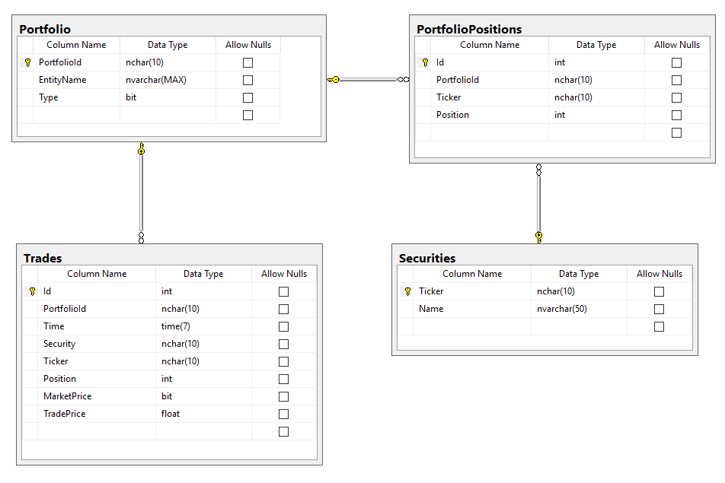

There are four tables to record data:

* Portfolio: record portfolio, there is no NAV in the table, the NAV will be calculated base on asserts
* PoftfolioPositions: record the securities that belong to portfolio, one portfolio may have multi records
* Trades: record every single trade detailed information
* Securities: record all valid security that user can trade. There is no price in this table, because I think the price is always change and will be fetch from other real time platform.

Please find the scripts for creating these tables.

1. Web backend

I defined a Domain project , which include the entities.

Class Portfolio : Include portfolio data such as portfolioId, protfolioName, Type, securityHoldList. And methods to record trade, and methods to maintain securityHoldList.

Security : model for a single security

SecurityLine: model for a item in securityHoldList

1. Web Frontend

There are several choice to implement frontend, such as MVC, Angular or other frontend framework.

1. Others

This system need real time communication, could use SignalR.

Promise, the asynchronous support.

Richard Duan

0481 719 796

kfduan@gmail.com